6. Write a program to demonstrate multiple inheritance through interface
CODE:
interface Drawable{

// abstract method
void draw();
}

interface Colorable{

void setColor(String color);
}

class Circle implements Drawable, Colorable{

private String color;

@Override
public void draw(){

System.out.println("Drawing a circle");
}

@Override
public void setColor(String color){

this.color = color;
System.out.println("Circle color set to: " + color);
}
}

public class TestInterface{

public static void main(String[] args){

Circle c = new Circle();
c.draw();
c.setColor("Red");
}
}

OUTPUT:-
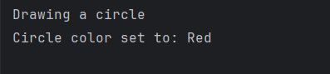

7 .Write a program to illustrate exception using multiple catch statement.
CODE:-
class MyException extends Exception
{
MyException(String message)
{
super(message);
}
}
class TestMyException {
public static void main(String args[])
{
int x=5, y=1000;
try
{
float z =(float)x/(float)y;
if(z<0.01)
{
throw new MyException("number is too small");
}
}
catch(MyException e){
System.out.println("caught MyException");
System.out.println(e.getMessage());
System.out.println(e);
}
catch(Exception e){
System.out.println(e);
}
finally
{
System.out.println("I am always here");
}

}
}
OUTPUT:
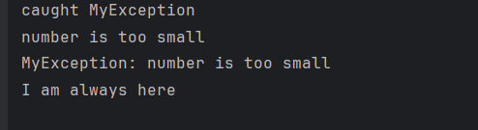

8. Program to create Lamp using Applet
CODE:-
import java.applet.Applet;
import java.io.*;
import java.awt.Graphics;

public class AppletLamp extends Applet
{
public void paint(Graphics g)
{
g.fillRect(0,250,290,290);

g.drawLine(125, 250, 125, 160);
g.drawLine(175, 250, 175, 160);

g.drawArc(85, 157, 130, 50, -65, 312);
g.drawArc(85, 87, 130, 50, 62, 58);

g.drawLine(85, 177, 119, 89);
g.drawLine(215, 177, 181, 89);

g.fillArc(78, 120, 40, 40, 63, -174);
g.fillOval(120, 96, 40, 40);
g.fillArc(173, 100, 40, 40, 110, 180);
}

}

OUTPUT:
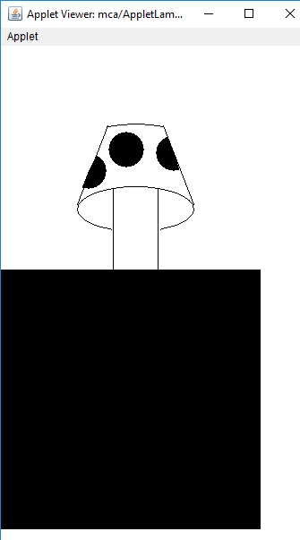

9 Write a program to create an application which shows the menu.

import java.awt.Frame;
import java.awt.Menu;
import java.awt.MenuBar;
import java.awt.MenuItem;

class MyMenu extends Frame {
MenuBar bar;
Menu menu1, menu2, menu3;
MenuItem MenuItem1, MenuItem2, MenuItem3, MenuItem4;
MyMenu(String s)
{
super(s);
setSize(400, 400);
bar= new MenuBar();
menu1 = new Menu("FILE");
menu1 = new Menu("EDIT");
menu1 = new Menu("VIEW");

MenuItem1= new MenuItem("NEW");
MenuItem2= new MenuItem("OPEN");
MenuItem3= new MenuItem("SAVE");
MenuItem4= new MenuItem("EXIT");

menu1.add(MenuItem1);
menu1.add(MenuItem2);
menu1.add(MenuItem3);
menu1.add(MenuItem4);

bar.add(menu1);
bar.add(menu2);
bar.add(menu3);

setMenuBar(bar);
}
public static void main(String args[])
{
MyMenu m = new MyMenu("MyMenu");
m.setVisible(true);

}
}
OUTPUT:
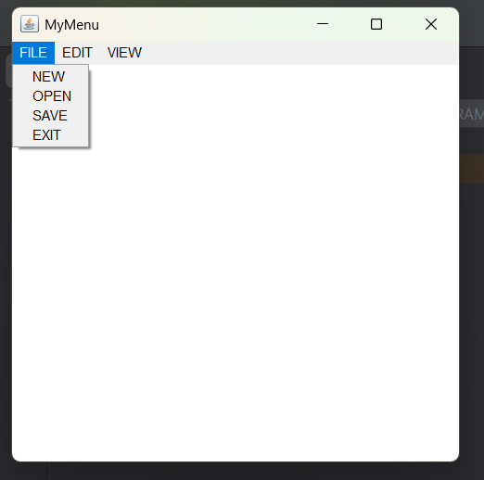
10. Write a program for creation of input dialog box.

import java.awt.FlowLayout;
import java.awt.event.ActionEvent;
import java.awt.event.ActionListener;

import javax.swing.JApplet;
import javax.swing.JButton;
import javax.swing.JFrame;
import javax.swing.JLabel;
import javax.swing.JOptionPane;

public class TenActionInputDialog extends JApplet implements ActionListener{
private static final long serialVersionUID = 1L;
JFrame jf;
JButton b1;
JLabel l1;

public TenActionInputDialog ()
{
jf=new JFrame("Demo of an Input dialog box");
l1= new JLabel();
jf.setLayout(new FlowLayout());
jf.setDefaultCloseOperation(JFrame.EXIT_ON_CLOSE);
b1= new JButton("Name");
b1.addActionListener(this);
jf.setSize(350,200);
jf.add(b1);
jf.add(l1);
jf.setVisible(true);
}

public void actionPerformed(ActionEvent e)
{
if (e.getSource()==b1)
{
int i = JOptionPane.QUESTION_MESSAGE;
String pstr = JOptionPane.showInputDialog(jf, "What is your name?"," Input Dialog Box",i);
l1.setText("Your name is :" +pstr);
}
}

public static void main(String str[])
{
TenActionInputDialog aid = new TenActionInputDialog();

}
}

Output:

